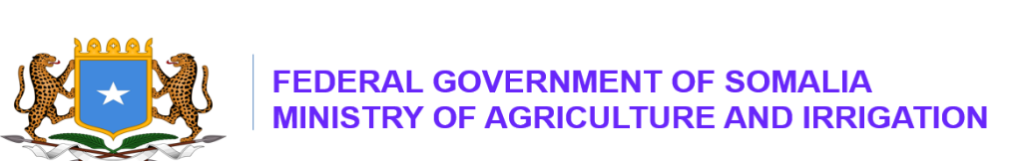

PRESS RELEASE

The 2nd National Agri‑Food Investment Summit (NAFIS 2026) Accelerates Investment to Transform Somalia’s Agri‑Food Systems for a Sustainable and Resilient Future

Mogadishu, Somalia – August 12, 2026: The Federal Ministry of Agriculture and Irrigation (MoAI), led by H.E. Mohamed Abdi Hayir (Maareeye), successfully concluded the two-day 2nd National Agri-Food Investment Summit (NAFIS 2026), held at Jazeera Palace Hotel in Mogadishu from August 11–12, 2026. This year’s summit was convened under the theme: “From Commitments to Action: Accelerating Investment to Transform Somalia’s Agri-Food Systems for a Sustainable and Resilient Future’’.

The 2nd NAFIS 2026 delivered concrete outcomes that move Somalia decisively from commitments to action in investing and transforming its agri-food systems. The Summit reinforced national efforts to build a resilient agri-food sector capable of reducing food imports, increasing domestic production, expanding export opportunities, and contributing to long-term food sovereignty and economic growth.

H.E. Hamza Abdi Barre, Prime Minister of the Federal Republic of Somalia, officially inaugurated the Summit. He commended MoAI for its leadership in advancing Somalia’s agri-food investment agenda and reaffirmed the government’s commitment to strengthening food sovereignty during a period of global food insecurity. The Prime Minister highlighted Somalia’s significant agricultural potential, noting its vast arable land, river systems, and groundwater resources.

He stated:
“I commend the Ministry of Agriculture and Irrigation for its leadership in advancing this national agenda and mobilizing investment in our food systems. Somalia spent more than $2.2 billion on food imports in 2025. I urge Somali businesses and investors to redirect more capital into domestic agriculture and food production, reduce dependence on imported food, and retain more foreign currency within our economy. We are committed to securing markets for Somalia’s agri-food products, including China and several African countries, under favorable tariff arrangements.”

H.E. Mohamed Abdi Hayir (Maareeye), Minister of Agriculture and Irrigation, delivered high-level remarks during both the opening and closing sessions of the Summit, alongside with Ministers of Finance, Environment and Climate Change, and Commerce and Industry. Minister Maareeye emphasized that NAFIS is a flagship national platform designed to mobilize Somali businesspeople and financial institutions to invest in modernizing the country’s agri-food systems.

He stated:
“I extend my sincere appreciation to H.E. Prime Minister Hamza for his continued support and strong national commitment to advancing investment in Somalia’s agri-food systems. Today, I call upon Somali business leaders and domestic financial institutions to invest in and transform our agri-food systems into modern, sustainable, and commercially competitive agricultural production led by efficient food-processing and agribusiness companies.”

The Summit convened over 400 participants, including representatives from the Federal Government of Somalia, Federal Member States, development partners, local investors, banks, micro-finance institutions (MFIs), academia, experts, and farmers. Participants expressed strong commitments to accelerating investment, strengthening value chains, and advancing Somalia’s agricultural transformation.

Eng. Mohamed Hassan, Director General of MoAI, has appreciated MoAI staff and RLRP-IFAD, FRSP-World Bank and. FAO and WFP for their financial and technical contributions of this summit.

