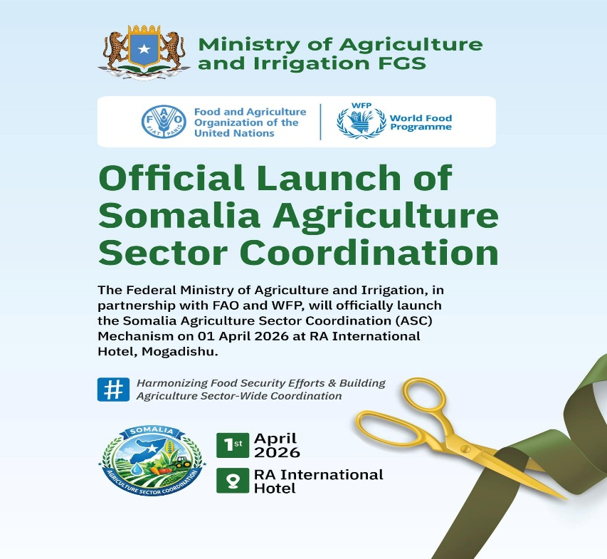

JOINT PRESS RELEASE

Official Launch Somalia Agriculture Sector Coordination Mechanisms

Mogadishu, Somalia – April 1st, 2026: The Federal Ministry of Agriculture and Irrigation (MoAI), in collaboration with FAO and WFP, held a high‑level launch event for the government‑led Agriculture Sector Coordination (ASC) mechanism at the RA International Hotel in Mogadishu, Somalia.

The event successfully inaugurated and operationalized the Somalia Agriculture Sector Coordination Mechanism, securing high‑level endorsement and collective stakeholder commitment. Participants approved the governance structure and operational framework, agreed on the immediate next steps, and endorsed the implementation roadmap. The event demonstrated Somalia’s strong commitment.

H.E. Salah Ahmed Jama, Deputy Prime Minister of the Federal Government of Somalia, inaugurated the Agriculture Sector Coordination platform. He commended the Ministry of Agriculture and Irrigation, along with its partners FAO and WFP, for establishing this highly significant mechanism.

“This initiative, which brings together productive‑sector ministries, government agencies, and international partners, will align our collective efforts to strengthen agricultural production and enhance food security through a unified national framework for advancing Somalia’s agriculture sector. It will boost production, improve farmers’ livelihoods, and build resilience to drought and climate change,” said Deputy Prime Minister Salah Ahmed Jama.

The ASC is fully aligned with Somalia’s Agriculture Transformation Strategy (2025–2029) and the National Transformation Plan (2025-2029), and serves as a key platform for ensuring coordinated, evidence-based, and results-oriented interventions across the agriculture sector. It is aligned with the United Nations Sustainable Development Cooperation Framework (UNSDCF) 20256-2030, particularly in advancing food security, climate resilience, inclusive economic development, and institutional strengthening.

H.E. Mohamed Abdi Hayir (Maareeye), Minister of Agriculture and Irrigation of the Federal Republic of Somalia, delivered official remarks during the launch of the Agriculture Sector Coordination. He emphasized the importance of the new mechanism, stating: “The Agriculture Sector Coordination addresses long‑standing inefficiencies and fragmentation within the agricultural sector by reducing duplication of interventions and improving resource efficiency through strategically planned and transparently monitored investments. Today, we have launched a government‑led ASC to coordinate development, recovery, and durable solutions across Somalia’s agri‑food systems.”

The high‑level event proceeded smoothly, featuring insightful remarks from H.E. Ahmed Hassan Aden, Minister of Fisheries and Blue Economy; General H.E. Bashir Mohamed Jama (Bashir Goobe), Minister of Environment and Climate Change; as well as ambassadors and heads of international partner organizations.

Mr. George Conway, Deputy Special Representative of the Secretary-General, Resident and Humanitarian Coordinator for Somalia, explained that the Agriculture Sector Coordination is a critical step toward strengthening national ownership, improving partner alignment, and delivering more effective and sustainable outcomes for Somali farmers and communities. He emphasized that the platform embodies the United Nations’ commitment to “Delivering as One” under the UNSDCF, ensuring that humanitarian, development, and resilience interventions are better integrated and aligned with government priorities. He further highlighted the importance of moving from fragmented projects toward a systems-based approach that supports long-term transformation of Somalia’s agriculture sector.

Mr. Etienne Peterschmitt and Mr. Hameed Nuru, FAO and WFP Representatives to Somalia, co-launched and expressed their strong commitment and collaboration for successful Agriculture Sector Coordination, expressing, “FAO and WFP reaffirm their joint commitment to supporting the Government of Somalia in operationalizing the Agriculture Sector Coordination Platform. Through our complementary mandates, we will continue to strengthen national systems, enhance coordination mechanisms, and promote integrated approaches that link agricultural production, food security, nutrition, resilience and agri-food transformation. This platform will enable us to bridge humanitarian and development efforts, scale up climate-resilient and market-oriented interventions, and support inclusive food systems transformation for the benefit of all Somalis.”

The launch brought together more than 100 high‑level participants, including Federal Government ministers, director generals, and heads of national agencies, alongside senior representatives from eleven UN agencies, ambassadors and diplomatic missions, international NGOs and consortia, as well as private‑sector actors and farmers. Together, they reaffirmed their commitment to working with the Ministry, in its role as Chair of the Agriculture Sector Coordination, alongside FAO and WFP as Co‑Chairs, to establish a unified framework for coordination, partnership, and collective ownership for a fully functional Agriculture Sector Coordination, facilitating joint planning, information sharing, partner mapping, and resource mobilization.

For more inquiries, please contact the Ministry of Agriculture and Irrigation.

